Planning and Progress Report



**Group Number:** C1.037  
**Repository:** <https://github.com/DP2-C1-037/Acme-ANS-D01>

**Workgroup Members:**

Student 1: Ignacio Gutiérrez Serrera - [igngutser@alum.us.es](mailto:igngutser@alum.us.es)

Student 2: Adrián Chabrera Rubio - [adrcharub@alum.us.es](mailto:adrcharub@alum.us.es)

Student 3: Miguel Álvarez Raya - [migalvray@alum.us.es](mailto:migalvray@alum.us.es)

Student 4: Salma El Hakimy - [salel@alum.us.es](mailto:salel@alum.us.es)

Student 5: Alejandro González Macías- [alegonmac@alum.us.es](mailto:alegonmac@alum.us.es)

**Date:** 05/03/2025

Table of Contents

1 Executive Summary 2

2 Revision Table 3

3 Introduction 4

4 Contents 5

4.1 Planning 5

4.1.1 TASKS 5

4.1.2 BUDGET ESTIMATION 8

5 Conclusions 9

6 Bibliography 10

# Executive Summary

This report details the planning and progress of the second deliverable, including task estimations, budget considerations, and work distribution among team members. The planning section outlines the tasks necessary to complete the deliverable, including descriptions, assignees, and estimated time commitments. It also includes screenshots documenting different phases of the development process and a budget estimation covering personnel and amortization costs. The progress section, on the other hand, highlights performance metrics, conflict resolutions, and a comparison between estimated and actual costs. This structured approach ensures transparency and accountability in project execution.

# Revision Table

|  |  |  |
| --- | --- | --- |
| **Revision Number** | **Date** | **Description** |
| 1.0 | 05/03/2025 | Initial Draft (Estimations) |
| 1.1 | 12/03 | Add progress data |

# Introduction

This document presents the Planning and Progress Report for Deliverable 02. It aims to track the tasks, resources, and development stages involved in the project. The planning section details the tasks required, including estimated time allocations and assigned roles. The progress section evaluates the project's evolution, comparing estimated and actual efforts, resolving conflicts, and documenting team performance.

The report is structured into three main sections:

* **Planning Chapter:** Includes task listings with estimated times, development phase screenshots, and budget estimations.
* **Progress Chapter:** Contains progress records, conflict resolutions, and a financial comparison between planned and actual costs.
* **Conclusions Section:** Summarizes the key findings of the report, reflecting on the efficiency of the planning process and the project's overall performance.

# Contents

This section details the key aspects of the project, including planned tasks, estimated time allocations, assigned roles, and budget considerations. Each task follows the format:

**[Task Name]**:

* **Description**: [description]
* **Assignee - Role**: [Student – Role]
* **Planned Time**: [time]
* **Actual Time**: [time]

## Planning

### TASKS

* **Set Up New Workspace Configuration:**
  + Description: Set up the new Workspace Configuration following the video posted on EV.
  + Assignee - Role: Student 5 – Developer
  + Planned Time: 0h 45 min
  + Actual Time: 0h 41min
* **Dashboard Planning:**
  + Description: Create every task that will be performed during Deliverable 02 along with its description, assignee, type and status.
  + Assignee - Role: Student 5 – Developer
  + Planned Time: 1h
  + Actual Time: 1h 13min
* **Technician Entity Creation:**
  + Description: The technicians care of aircraft maintenance by conducting regular inspections, performing repairs, and carrying out other maintenance tasks. The system must store the following data about them: a license number (unique, pattern "^[A-Z]{2-3}\d{6}$"), a phone number (pattern "^+?\d{6,15}$"), their specialisation (up to 50 characters), whether they have passed their annual health test or not, and their years of experience. Optionally, the system may store their certifications (up to 255 characters).
  + Assignee - Role: Student 5 – Developer
  + Planned Time: 0h 30min
  + Actual Time: 0h 27min
* **Maintenance Record Entity Creation:**
  + Description: Maintenance records are comprehensive records of activities performed on a given aircraft throughout its operational life. The system must store the following data about them: the moment when a maintenance takes place, its status ("PENDING", "IN PROGRESS", "COMPLETED"), the next inspection due date, an estimated cost, and some optional notes (up to 255 characters).
  + Assignee - Role: Student 5 – Developer
  + Planned Time: 1h
  + Actual Time: 2h 43min
* **Task Entity Creation:**
  + Description: Maintenance records rely on tasks. A task is a specific predefined operational duty carried out by a technician on aircrafts. The system must store the following data about tasks: their type ("MAINTENANCE", "INSPECTION", "REPAIR", "SYSTEM CHECK"), a description (limited to 255 characters), a priority (ranging from 0 to 10), and an estimated duration (in hours).
  + Assignee - Role: Student 5 – Developer
  + Planned Time: 1h
  + Actual Time: 0h 40min
* **Produce UML Domain Model:**
  + Description: Produce a UML domain model regarding the information requirements.
  + Assignee - Role: Student 5 – Developer
  + Planned Time: 1h
  + Actual Time: 4h 37min
* **Store Information about Technicians Dashboard:**
  + Description: The system must handle technician dashboards with the following indicators: the number of maintenance records grouped by their status, the maintenance record with the nearest inspection due date, provided that he or she is involved in any tasks that need to be performed as part of that maintenance, the top five aircrafts with higher number of tasks in their maintenance records, the average, minimum, maximum, and standard deviation of the estimated cost of their maintenance records in the last year, the average, minimum, maximum, and standard deviation of the estimated duration of the tasks in which he or she is involved.
  + Assignee - Role: Student 5 – Developer
  + Planned Time: 3h
  + Actual Time: 0h 55min
* **Produce Test Technician Sample Data:**
  + Description: Produce assorted sample data to test the application informally. The data must include two technician accounts with credentials “technician1/ technician1” and “technician2/ technician2”. Create an additional technician account with credentials “technician3/ technician3” that represents a technician with no data, but his or her profile.
  + Assignee - Role: Student 5 – Developer
  + Planned Time: 3h
  + Actual Time: 10h 33min
* **Provide Link to Dashboard:**
  + Description: Provide a link to the Deliverable 02 Student 5 Dashboard.
  + Assignee - Role: Student 5 – Developer
  + Planned Time: 0h 5min
  + Actual Time: 0h 3min
* **Store Information About Technician Dashboards:**
  + Description: Store information about the technicians’ dashboards.
  + Assignee - Role: Student 5 – Developer
  + Planned Time: 1h
  + Actual Time: 0h 55min
* **Store Information About Courses for Technicians**:
  + **Description**: The system is required to have a notice board to advertise courses for technicians. A web service must be used to populate this entity with information about courses. Select a service that provides with courses information and create an entity that uses that data.
  + **Assignee - Role**: Student 5 - Developer
  + **Planned Time**: 3h
  + **Actual Time**:
* **Produce Analysis Report**:
  + **Description**: Create an analysis report using the "Annexes" document.
  + **Assignee - Role**: Student 5 - Developer
  + **Planned Time**: 1h
  + **Actual Time**:
* **Produce Planning and Progress Report**:
  + **Description**: Create a Planning and Progress Report using the "Annexes" document.
  + **Assignee - Role**: Student 5 - Developer
  + **Planned Time**: 3h
  + **Actual Time**:
* **Start Deliverable Planning Considerations:**
  + Description: Start the Planning and Progress Report with initial Planning estimates and considerations.
  + Assignee - Role: Student 5 – Developer
  + Planned Time: 1h 30min
  + Actual Time: 2h 5min
* **Mid Deliverable Planning and Progress Considerations**:
  + **Description**: Update the Planning and Progress Report considering the current state of the deliverable (progress, due time, etc.) and new estimates.
  + **Assignee - Role**: Student 5 - Developer
  + **Planned Time**: 0h 30min
  + **Actual Time**: 0h 27min
* **End Deliverable Progress Considerations**:
  + **Description**: Update and end the Planning and Progress Report considering the state of the requirements and comparing it to the initial estimates.
  + **Assignee - Role**: Student 5 - Developer
  + **Planned Time**: 1h
  + **Actual Time**:

### SCREENSHOTS

* Start of the delivery:

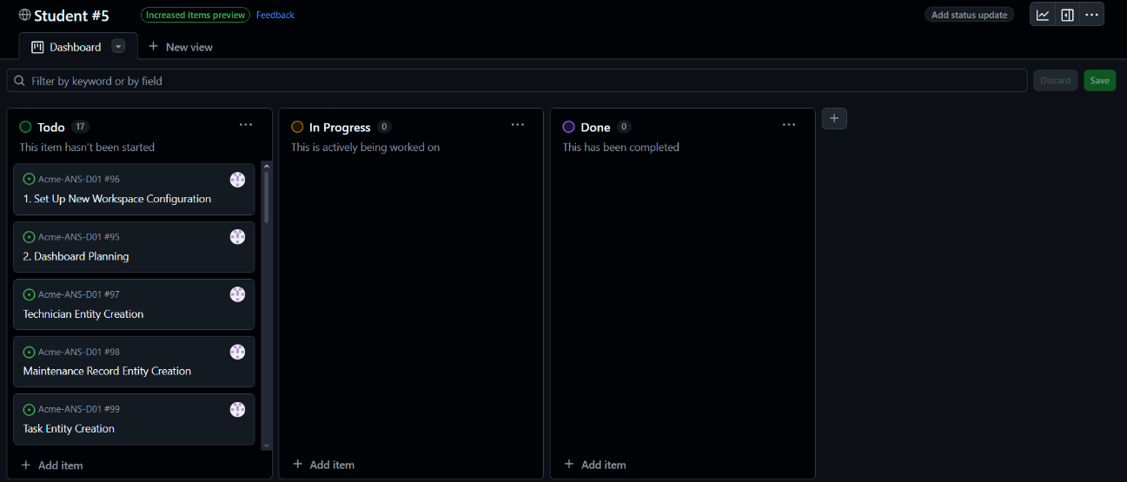

* Middle of the delivery:

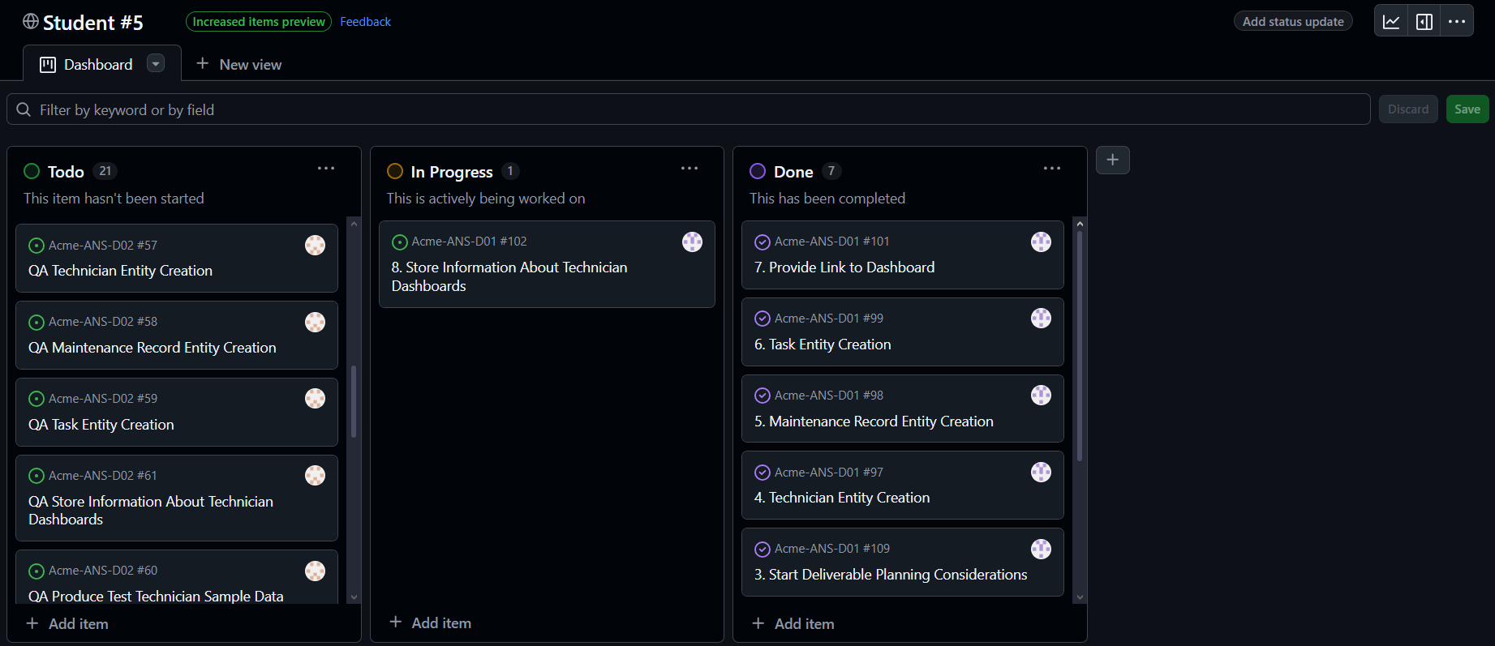

* End of the delivery:

### BUDGET ESTIMATION

|  |  |  |  |  |  |  |
| --- | --- | --- | --- | --- | --- | --- |
| Role | Estimated Hours | Real hours | Cost per Hour (€) | Estimated Cost (€) | Real cost | Amortisation Cost |
| Developer, tester | 22 |  | 20 | 440 | 311 | 19.67 |

Amortisation cost is computed using a linear depreciation method over three years:

annual_amortisation_cost = (real_cost - estimated_cost) / amortisation_period_years -> (real_cost - estimated_cost) / 3

## Progress

### PROGRESS RECORDS

**Team Member**: Alejandro – Student 5  
**Performance Indicator**: I have completed my mandatory, supplementary I and supplementary II tasks.  
**Evaluation**: Great  
**Reward/Admonishment**: recognition from the group.

### COST COMPARISON

**Cost Comparison:** remit to point 4.1.3 for budget comparison.

# Conclusions

This report provides an in-depth view of the planning and progress tracking for Deliverable 02. The estimated time and budget allocations ensure an organized workflow. The methodology ensures that the project is structured effectively while maintaining accountability through tracked progress metrics. The cost estimations offer a financial overview that can be compared to actual expenditures upon project completion.

# Bibliography

Intentionally blank.